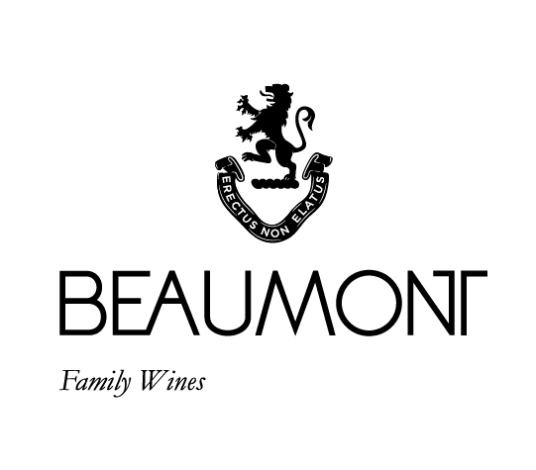

ARIANE CABERNET FRANC| 2022

The Ariane as a blend was first produced in 1998. Since then, it has evolved with the vintages and the maturation of the vines. Our wine club the “The Kin” has given me great opportunities to look at the single varietals that went into the original blend. My favourite since 2004 has always been the Cabernet Franc portion. Now a key element in our Vitruvian blend where it adds its distinct personality and beautiful perfume. It brings me such joy to announce that this wonderful wine is now available as Beaumont Ariane.
The 2022 was dry and cool and produced very intese wines with a wonderful open and approachable expression. Medium weighted with fine grainy tannins and an inviting perfume of black fruit and spice make this young wine very interesting to taste and drink. It will mature very well if you can hang onto a few bottles for 5 to 8 years.

FOOD PAIRING | Best suited to classic red meat dishes. But let this wine mature and you will be able to enjoy it on its own.
PACKAGING | 6 x 750 ml

RATINGS & REVIEWS | Not been reviewed yet but it is a beautiful wine that if you get your hands on bottle or two it will be worth it!

CULTIVAR

100% Cabernet Franc
pH

3.48

RS

1.5 g/L

TA

5.8 g/L

ALC

13.01%

BALLING AT HARVEST

22.5°
Balling

VINEYARD
AGE
.

5 yrs

BOTTLES
PRODUCED

1684 x 750ml bottles

APPELATION

Bot River

YIELD

6
tons / ha

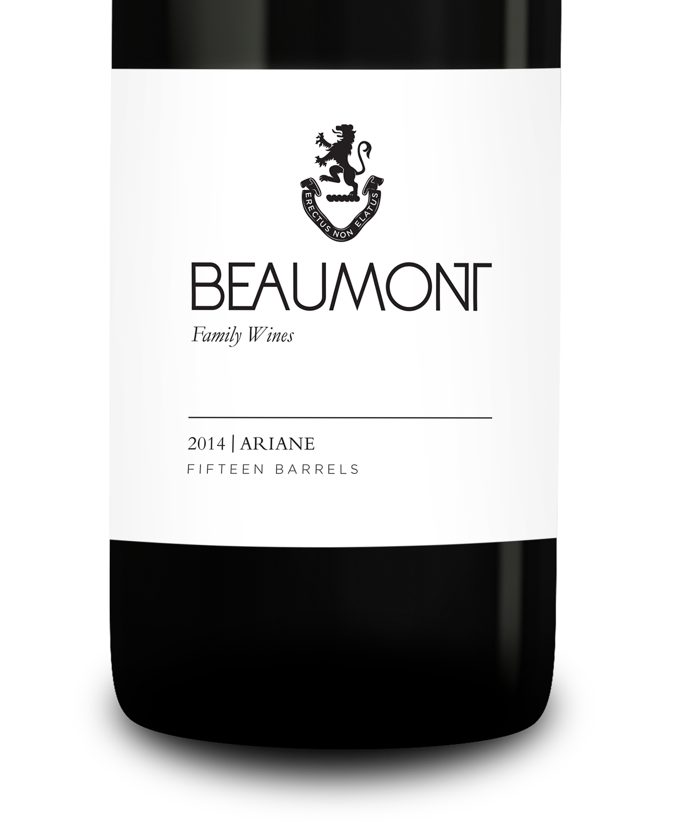
WINE MAKER | Sebastian Beaumont.

VINTAGE CONDITIONS | 2022 is a richer vintage than 2021. It produced wines with great intensity and balance. Dry conditions produced small yields of healthy fruit.

VINIFICATION | After the grapes were cold soaked for 2 days till natural fermentation started. A warm ferment of 28-30 °C was allowed with 2 hourly punch downs in an open vat. Six days of fermentation with three weeks post maceration then pressed directly into barrel.

MATURATION | Maturation in French oak for 14 months.

AGEING POTENTIAL | 4- 8 years.

