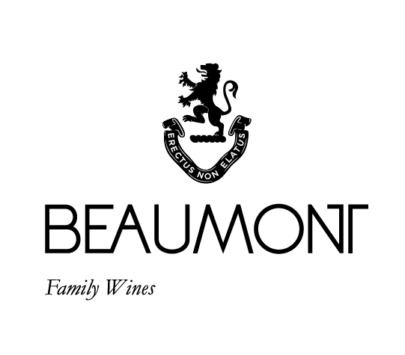

VITRUVIAN BLEND | 2019

Why Vitruvian? The key component of our 250 yr old water mill is known as a Vitruvian Mill. We wanted to connect this unique wine to the history of the farm. The Beaumont family have been farming the vineyards on the farm since 1974 and it is with this experience and understanding of our unique terroir that we decided to produce this special blend. Our philosophy with all our wines is to produce a pure expression of place. We prefer elegance over power and want this blend to be the sum of its component parts. 60% of the 2017 blend was co-fermented to allow the varietals to integrate from a very early stage.

FOOD PAIRING | Coq au vin, Italian sausage pasta, or a great piece of steak with spices such as cumin, pepper and coriander enhancing the natural spice of the wine.
PACKAGING | 6 x 750 ml

RATINGS & REVIEWS | The first vintage produced from the 2006 crop and this wine received fantastic reviews. Elegance was one of the main factors behind this blend. The 2017 is the first vintage to receive Platter 5 Star rating.

BOTTLES
PRODUCED

2220 and 40 magnums

VINEYARD
AGE
.
17 - 46 yrs

CULTIVAR

44% Mourvèdre
18% Cabernet Franc
16% Syrah
13% Petit Verdot
9% Pinotage

pH

3.46

RS

1.7 g/L

TA

5.8 g/L

ALC

12.45%

BALLING AT HARVEST

23° - 24.5°
Balling

YIELD

3 - 5
tons / ha

APPELATION

Bot River

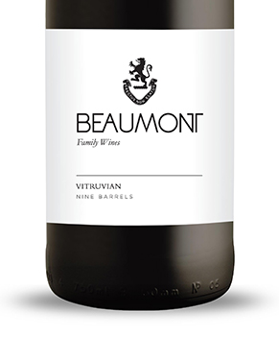
WINE MAKER | Sebastian Beaumont.

VINTAGE CONDITIONS | Probably one of the best vintages on Beaumont in the last 8 years. The 2019 vintage was dry but brought a beautiful intensity to the fruit.

VINIFICATION | We co-fermented 60% of the key components of this blend. The aim was to get very early integration of the varietals. The other 40% of the blend was kept as separate portions and blended in over time.

MATURATION | 8 x 225L barrels made & matured for 36 months in French oak of which 35% was new.

AGEING POTENTIAL | 10 - 15 years.

