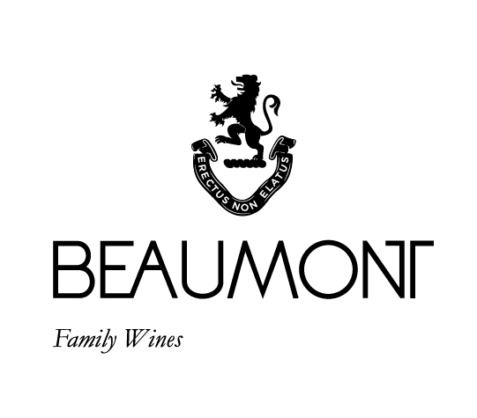

New Baby | 2021

My dream was to create a white blend to partner the Vitruvian. The first name that came to mind was “New Baby”. I wrote this on the barrels and so the first vintage was born. I have kept the blend ratio similar through the different vintages to allow the vintage to show its identity in the wine. This is the first vintage without Chardonnay in the blend.
All our best old vine white cultivars are used in the blend. The Chenin was planted in 1974 & 1978, Sauvignon Blanc 1983, Semillon 1997 and Colombar 1988. Each cultivar brings its own unique personality to the blend that ultimately makes this wine incredibly complex and fascinating.
FOOD PAIRING | Delicate and rich at the same time this is a wine that can be enjoyed on its own and with something delicious from the ocean. Scallops for sure!
PACKAGING | 6 x 750 ml

RATINGS & REVIEWS | First vintage has been given 5 stars in the Platter Wine guide. Tim Atkin Review gave it 95 points and selected it as one of the top white wines.
The 2021 vintage also received a Platter 5 star rating.

BOTTLES
PRODUCED

1986 bottles

VINEYARD
AGE
.
20-47 yrs

CULTIVAR

43% Chenin Blanc
22% Sauv Blanc
17% Semillon
18% Colombar

pH

3.33

RS

3.7 g/L

TA

6.0 g/L

ALC

12.55%

BALLING AT HARVEST

21° - 22.5°
Balling

YIELD

3 - 5
tons / ha

APPELATION

Bot River

WINE MAKER | Sebastian Beaumont.

VINTAGE CONDITIONS | Healthy conditions produced perfect fruit. Harvesting took place pretty much at our normal time at the beginning of Feb.

VINIFICATION | All cultivars were treated independently and then blended very soon after harvest to get integration as early as possible. All naturally fermented in barrel with no new oak in this vintage.

MATURATION | 6 x 225L barrels made & matured for 12months in French oak of which 30% was new.

AGEING POTENTIAL | 10 - 15 years.

