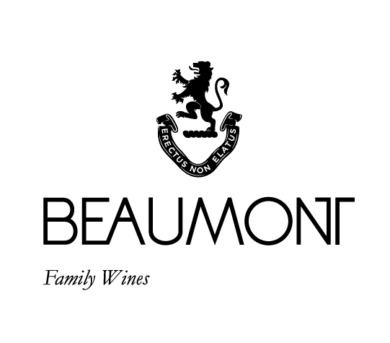

CHENIN BLANC | 2023

This is fruit filled unwooded Chenin Blanc. The 2023 vintage produced very healthy grapes full of flavour and great intensity. It is a delicious example of cooler climate Chenin Blanc fermented in concrete and stainless-steel tanks using a combination of cultured and natural yeasts. Matured after fermentation on the lees to add some extra weight and complexity to the wine.

FOOD PAIRING | Great with seafood, especially shellfish and spicy Thai and Indian curries.
PACKAGING | 6 x 750 ml in screw cap
BARCODE bottle 6009077000139 box 16009077000136

RATINGS & REVIEWS | Since our first vintage in 1996 we have committed to making a style of Chenin that captures the purity of the grape. Previous vintages have been regular 4 star wines in Platter.

VINEYARD
AGE

Ranging between 3 and 49 yrs

CULTIVAR

Chenin Blanc

BOTTLES
PRODUCED

95040
bottles

pH

3.25

RS

3.2g/L

TA

6.5g/L

ALC

13.44%

BALLING AT HARVEST

18.5° - 23.5°
Balling

YIELD

6 – 12
tons / ha

APPELATION

Cape South Coast

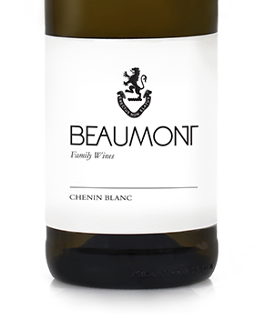
WINE MAKER | Sebastian Beaumont.

VINTAGE CONDITIONS | The 2023 vintage produced another year of great healthy fruit. It started off cold and wet but then it dried out. Rains in early December brought some much needed relief to the vineyards. Harvest started early in February with very good cool conditions.

VINIFICATION | Early picking to preserve freshness, and balance in the wine. Our new press produced gave us very clean juice and I think it has had a very positive effect on this vintage. Long slow fermentation.

MATURATION | Average of 4 months on gross lees in tank.

AGEING POTENTIAL | 2 - 5 years.

