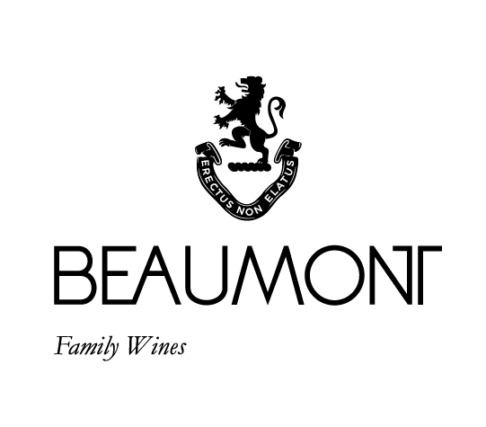

BEAUMONT JACKALS RIVER PINOTAGE | 2022

Pinotage was the very first wine made under the Beaumont label in 1994. Our oldest vines planted in 1974 still produce magnificent fruit and are key to making the medium bodied style of Pinotage we have become known for.
Our style reflects the cooler climate of the Bot River region. Harvested between mid-February and mid-March the grapes are then crushed into open concrete fermenters. Punched down 3-4 times per day until end of ferment, then pressed and taken to barrel for 14 months and then taken to tank for another 8 months. Fresh red berry fruit with a deliciously drinkable medium body and well-integrated tannins.

FOOD PAIRING | Matches very well with bobotie, game and curries, spare ribs and pepper steak, or try snoek and grape jam.
PACKAGING | 6 x 750 ml
BARCODE bottle 6009077000160 box 16009077000167

RATINGS & REVIEWS | A consistent 4 star winner in Platter. This is still an elegant style of Pinotage with red berry and ripe fruit flavours with fine tannins and lovely fruit on the palate.
Jancis Robinson wrote that the 2011 vintage was one of the best Pinotages she had ever tasted.

VINEYARD
AGE
.
Old Vines: 48 yrs; Younger vines:
4 and 25 yrs

YIELD

Old vines:
1.5 to 3 tons/ha; Younger vines:
3 -10 tons/ha

CULTIVAR

Pinotage

BOTTLES
PRODUCED

16292
bottles

pH

3.58

RS

2.0g/L

TA

5.6g/L

ALC

13.12%

BALLING AT HARVEST

23.5° - 25.5°
Balling

APPELATION

Bot River
Walker Bay

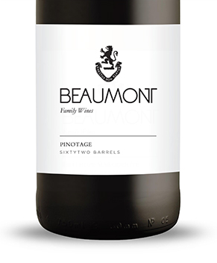
WINE MAKER | Sebastian Beaumont.

VINTAGE CONDITIONS | A normal wet cold winter allowed for good rest of the vines. Healthy ripening season produced perfect grapes resulting in fantastic juice.

VINIFICATION | Grapes were harvested and crushed directly into concrete open fermenters, a few days cold soak and then a controlled fermentation with regular punch downs. This 2022 vintage allowed us to extract gently and produce wines with very good weight and structure.

MATURATION | 14 months in 100% French oak. 20% new oak.

AGEING POTENTIAL | 8 – 15 years

