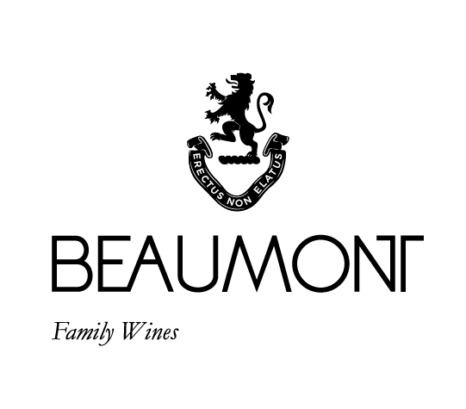

DANGERFIELD SYRAH | 2022

A complex wine from 3 different vineyard sites on our property. As the vines mature their metabolism slows and the grapes produce wines with greater complexity.
Good colour, spicy fruit and pepper on the nose and flavours of berry fruit with fine ripe tannins on the finish make this a full but elegant wine.
The name Dangerfield comes from a character in one of Raoul's favourite novels The Ginger Man written by JP Donleavy. When Sebastian was born Jayne and Raoul tried to use it as a middle name for him. Unfortunately, the grandparents revolted and vetoed the decision. Finally, a wine has received the honour.
RATINGS & REVIEWS |
The 2016 received a Gold at the Old mutual Trophy show. The 2017 was selected by Decanter Magazine as one of their top 10 South African Syrah’s in a 2020 review.
2019 Received 92 points in Tim Atkin review. 93 Points in Platter wine guide. The 2020 was rated 93points in Platter.

FOOD PAIRING | Spicy red meat – pulled pork or roasted lamb go very well with this wine.
PACKAGING | 6 x 750 ml
BARCODE bottle 6009077000177 box 16009077000174

VINEYARD
AGE
.
18 - 27 yrs

CULTIVAR

100% Syrah

BOTTLES
PRODUCED

5033 x 750ml

pH

3.60

RS

1.9 g/L

TA

5.6 g/L

ALC

13.28%

BALLING AT HARVEST

21.5° - 23.5°
Balling

YIELD

2 - 5
tons / ha

APPELATION

Bot River
Walker Bay

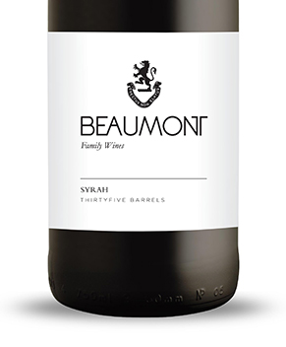
WINE MAKER | Sebastian Beaumont.

VINTAGE CONDITIONS | 2022 was a normal wet cold winter that allowed the vines to get some good rest. Healthy ripening season produced perfect grapes resulting in fantastic juice.

VINIFICATION | Picked at 21.5° - 23.5° balling, crushed and cold soaked for 3 days to extract optimum colour and flavour. The different vineyards were fermented separately, with all portions undergoing a natural fermentation to add complexity to the final blend. 30- 40% whole bunches were added to the ferment. Fermented in open concrete Kuipe. Malolactic fermentation in tank and then taken to barrel.

MATURATION | 18 months in 100% French oak barrels.

AGEING POTENTIAL | 8 – 10 years.

