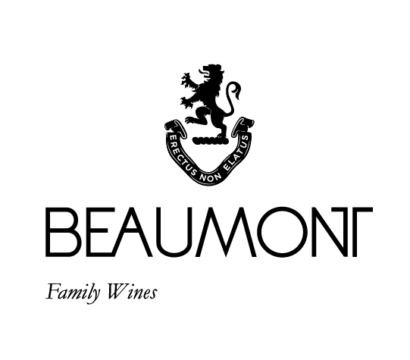

FAR SIDE MOURVÈDRE | 2020

Beaumont Family Wines were the first winery in South Africa to bottle a single varietal Mourvèdre.
Originally the grape comes from Spain and France where it is mostly used to enhance blends. Mourvédre's dark, thick-skinned berries result in powerful spicy and sometimes gamey aromas in their youth. The old French saying goes as follows: “Mourvèdre needs to be planted with its head in the sun, its feet in cool soil and it must have a view of the sea”. Which is how the wine got the name Far Side. This connects to Sebastian passion for surfing and his favourite local surf break called “the Far Side”.
This unique wine was made from a small parcel of Mourvèdre with a low crop yield of 2 -4 tons/ha. Grapes were harvested at full ripeness, cold soaked, fermented in concrete tanks with 30% whole bunch and allowed a post maceration of 3 weeks, thereafter it was pressed directly into 100% French oak barrels.

FOOD PAIRING | Spicy roasted red meat or game, grilled pork or calf’s liver, rich hearty dishes such as paella with chorizo and hot spices.
PACKAGING | 6 x 750 ml

RATINGS & REVIEWS | I always say that this is a wine for freaks! It is not everyone’s darling. But we have set a benchmark for the varietal in South Africa and show how it can consistently produce interesting wine.

pH

3.57

RS

2.6 g/L

TA

5.5 g/L

ALC

13..41%

BALLING AT HARVEST

22.5° - 24°
Balling

YIELD

2- 4
tons / ha

VINEYARD
AGE
.
25 yrs

APPELATION

Bot River

CULTIVAR

Mourvedre

BOTTLES
PRODUCED

3560 bottles

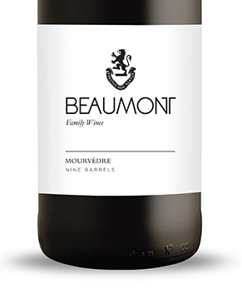
WINE MAKER | Sebastian Beaumont.

VINTAGE CONDITIONS | The most beautiful thing to come out of 2020 was the vintage. Super healthy conditions allowed us to make very pure and true expressions of our various wines.

VINIFICATION | After the grapes were cold soaked for 2 days till natural fermentation started. 30% of the bunches were added as whole bunches. A warm ferment of 28-30 °C was allowed with regular punch downs in an open vat. Six days of fermentation with three weeks post maceration then pressed directly into barrel.

MATURATION | Maturation in French oak for 18 months and 18 months in bottle.

AGEING POTENTIAL | 8 – 10 years.

